Part A: Application Cover Sheet  EGJ Working Groups Funding | 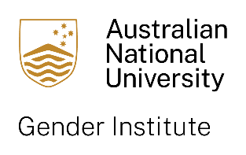

Enhancing Gender Justice through Transdisciplinary Research

ANU Gender Institute Working Groups Funding, Round 1 2024
Current members of the Gender Institute may request up to $80,000 AUD in Round 1.
This call opens on 1 October 2024 and closes at 5pm on 15 January 2025.
Outcomes will be notified by 1 March 2025.

Projects will run for 12-24 months and must commence within 6 months of award.
This funding program is separate from our normal grants rounds, with different funding criteria and reporting requirements. For full guidelines, please see our website.

Lead Applicant or Co-applicant Details
Name: | College/School/Institution:
Email:
Additional Working Group Researchers (please include ANU-based researchers only)
Name: | College/School/Institution:
Email:

Name: | College/School/Institution:
Email:

* Please add additional lines as necessary

Proposal Title and Summary*:
* Full project description must be provided separately in Part B: Application Details
Expected Timeline

Funding*
Total amount requested: $
* Full budget breakdown and justification to be provided separately in Part B: Application Details
Endorsement of ANU Supervisor or Divisional Director or College Dean*
Name:

Date: | Signature:
* In the first instance please seek supervisor approval for your application, but if the project requires it, Director or Dean endorsement should be sought.

