**MODALITIES & TERMS OF REFERENCE (ToR)**

of the

**INDIAN OCEAN RIM ACADEMIC GROUP (IORAG) EARLY-CAREER PROFESSIONALS (ECP) NETWORK**

1. **Background**

IORA has a strong focus on capacity building and knowledge sharing to promote regional cooperation and development, recognised through the establishment of the Indian Ocean Rim Academic Group (IORAG) as the first institutional mechanism when IORA was formed. With the recent strengthening of existing IORA mechanisms and establishment of new IORA mechanisms, this presents an opportune time to consider establishing a network of Early Career Professionals (ECP) to capitalise on the activities within IORA and create a platform to create awareness of IORA that can maintain the momentum of the Association.

IORA presents a unique opportunity for capacity development and networking as it provides a platform for academia, business, and government officials to engage. Introducing ECP to such a platform would be valuable in introducing them to the protocols of engagement in a high-level multi-lateral platform and sensitise them to the regional needs and capacities.

In order to sharpen the focus of the IORAG, it has been suggested that the following measures be considered:

1. Develop a stronger Indian Ocean Research environment with the IORAG serving as an academic “think tank” for the Association;
2. Foster a culture of Indian Ocean regional identity;
3. Focus on matters of common interest;
4. Conduct research aimed at enabling better regional policy outcomes;
5. Develop a stronger regional policy framework;
6. Help set the direction and strategic purpose for IORA’s academic cooperation policy agenda; and
7. Enhance collective regional awareness.

Establishing an ECP Network within the IORAG will create a platform for both regional and national networking and information sharing through peer-to-peer engagement and expand the capacity building outreach of IORA activities. The activities should also be aimed at assisting ECPs to connect on a peer-to-peer level when applying for funding of projects (whether related to IORA or other international funding instruments) to broaden their scope and networks and possible mentorship by the experts associated with the IORAG. Such a network would, therefore, assist in meeting many of the objectives of the IORAG.

1. **Vision of the IORAG ECP Network**

To promote the cooperation of Early-career Professionals within IORA through enhanced dialogue, research, and networking across all the IORA priority and cross cutting areas.

1. **Purpose and Objectives of the IORAG ECP Network**

Youth engagement and support for early-career professional’s development is a recognised part of most international programmes to ensure the continuation of programmes, and ensuring that incoming professionals have the required networks and skills to continue and improve on the work.

Since this network will be affiliated with the IORAG, and therefore under the priority area of Academic Cooperation, Science and Technology, the focus will be on supporting early-career government policy makers (in ministries of science, technology and innovation) and researchers/academics.

The objectives of the ECP Network will be to:

* 1. Provide a platform for ECPs to develop active connections and work collaboratively across the Indian Ocean.
  2. Ensure that experienced professionals share their knowledge with ECPs.
  3. Strengthen the IORAG to serve as a vehicle for the development and dissemination of the Indian Ocean Rim Concept and of relevant research undertaken in or about the Indian Ocean.
  4. Build and maintain the long-term visibility of IORA in Member States.

1. **Structure and Roles of the IORAG ECP Network**

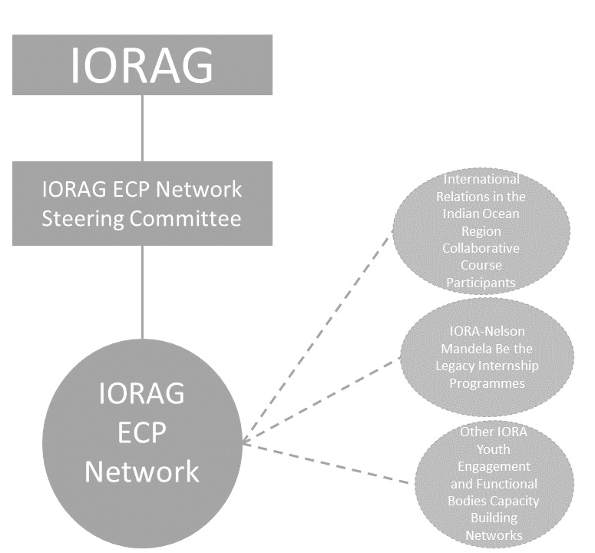

Figure 1: Structure of the IORAG ECP Network within the IORAG.

1. **Structure: IORAG ECP Network Steering Committee**
2. Criteria for Selection: Committee members must be employed (full-time or on contract for the duration of the two-year committee period) at a national government department, or nationally recognised university, research institution, or NGO, and working in one of the IORA priority areas or cross-cutting areas. Candidates must be under 37 years of age.
3. Committee Chairperson: The chairperson is the driving force behind the committee and is responsible for ensure all other committee members are fulfilling tasks assigned to them and stepping in when needed. The chairperson is responsible for reporting to the IORAG and the coordination of committee meetings.
4. Secretariat: The secretary works closely with the chairperson and internal stakeholder communicator managing ECP Network documents and administration. The secretariat is responsible for minute taking in all meetings and the distribution thereof.
5. Internal Stakeholder Communication: This portfolio deals with communication and interactions between the committee members, ECP Network members, IORAG and IORA Secretariat. The portfolio will be responsible for maintaining the ECP Network membership list, email account and mailing list.
6. External Stakeholder Communication: This portfolio deals with communication and interactions between the committee members and the public, including facilitating the compilation of newsletter articles and regular posting of relevant opportunities on appropriate social media platforms, in collaboration with the IORA Secretariat. The portfolio will be responsible for maintaining the ECP Network email account and mailing list.
7. IORAG Facilitator (non-voting position): The Facilitator will be a member of the IORAG (national IORAG Focal Point or a delegated representative) and provide the link between the ECPN Network and the IORAG, providing guidance and advice and ensuring the ECP Network maintains alignment with mandate of IORA and the IORAG, and the IORA Action Plan.
8. Observers (non-voting position): IORA/IORAG Member State and Dialogue Partner National Focal Points, IORA Secretariat, IORA-RCSTT and IORA-FSU, may attend committee meetings on an ad hoc basis to provide input and oversight of activities.
9. Committee Meetings: The committee will hold at least one quarterly meeting a year.
10. Participation in IORA Processes: Committee members may be allowed to attend IORA meetings (including Track 1) if nominated by their Member State, if is relevant to their career advancement, and it is approved by the host Member State.
11. **Structure: IORAG ECP Network**
12. Criteria for Selection: Participation will be open to all self-identified early-career professionals from Member States and Dialogue Partners, who have an interest in working within the IORA priority areas and cross-cutting areas.
13. The network will be an open online community cooperating for the development of the Indian Ocean Region.
14. **Role: IORAG**
15. IORAG members will facilitate the process for nominations and selection of the ECP Network Steering Committee. This may happen intersessionally, or at the annual IORAG meeting.
16. The IORAG will facilitate circulation of general capacity building opportunities offered by Member States (e.g., IORA Blue Carbon Hub Early-career Professionals Visiting Programme) through the IORAG ECP Network; through the IORAG Facilitator.
17. The IORAG should invite the ECPN Network Steering Committee to attend IORAG meetings. Consideration may be given to supporting ECP through the IORA Special Fund.
18. The IORAG will ensure at least one activity per year within the IORAG Work Plan focused on ECP Network capacity building. This could be in any of the IORA priority areas or cross-cutting areas. Consideration should be given to collaboration with the other IORA Functional Bodies.
19. **Role: IORAG ECP Network Steering Committee**
20. The committee, in collaboration with the ECP Network members IORAG Facilitator, will be responsible for developing an annual activity plan.
21. The committee will be responsible for creating visibility of IORA and the ECP Network.
22. **Role: IORAG ECP Network**
23. The network members will propose activities to the steering committee for consideration for implementation within the annual activity plan.
24. In collaboration with the ECP Network Steering Committee, the network will be responsible for creating visibility of IORA and the ECP Network.
25. **Language**

The working language of all IORAG ECP Network meetings will be English.

1. **Term of Office: ECP Network Steering Committee**
2. The committee members will act on the committee for a two-year period
3. A committee member may serve for a period of two consecutive terms only
4. **Responsibilities of the IORA Secretariat**
5. Providing administrative, logistical support including guidance on IORAG ECP Network meetings, on request of the Chair of the IORAG.
6. Maintaining archives and files of the Meetings.
7. Facilitating information sharing between participants, including circulating agendas and outcome reports to Member States and Dialogue Partners.
8. Provide guidance to the ECP Network Steering Committee in support of inter-sessional communications relevant to Member State’s National Focal Points.
9. Assist the IORAG Facilitator in sustaining the implementation of the decisions of the ECP Network by seeking and sharing regular progress reports.
10. Other activities as proposed by the IORAG, and as agreed by Member States, for the Secretariat to assist with the implementation of activities and meeting the objectives of the IORAG ECP Network.
11. **Annual Activities of the ECP Network**

The ECP Network Steering Committee will be responsible for developing an annual plan of activities, in consultation with the ECP Network participants and IORAG, which will be submitted to the IORA Secretariat for circulation to Member States.

1. **Amendment, Modification or Variation**

The Modalities and TOR may be amended, varied, or modified in writing after consultation and agreement by the IORAG Chair and Member States.

*****