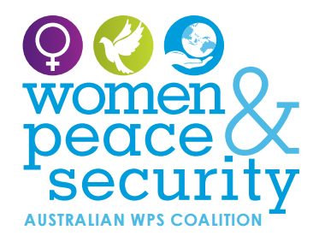

**Women’s voices must be heard!**

**Join us for a Civil Society Roundtable discussion on women, peace and security**

**What does peace mean to you? What does security mean? What should Australia be doing differently to build peace and security in Australia and our region?**

The global challenges of climate change, extreme poverty and inequality, armed conflict and widespread violations of human rights require global solutions which reflect the priorities, skills and experiences of all people. Yet, too often women’s voices are overlooked by Governments and policymakers.

**For diverse women in Australia and our region, this is a critical time to have our voices heard on peace and security** as Australia contemplates the next phase of its National Action Plan on Women, Peace and Security.

The Australian Civil Society Coalition on Women Peace and Security will hold a series of roundtables across Australia to provide opportunity for the diverse women living in Australia and our region to express their views on what peace and security means in practice. The Roundtables will provide a forum to discuss what the Australian Government can do, in co-operation with civil society, to limit the possibility of conflict within or between communities, states and countries, and to provide avenues for women’s participation in peace processes within Australia and internationally.

**Event Details**

**Join us in CANBERRA: *choose one event***

* **On 2 Sept from 9:30-12:30**

**At Friends Meeting House, cnr Bent and Condamine Sts, Turner.**

**Please book your space now** https://www.eventbrite.com.au/e/women-peace-and-security-canberra-roundtable-1-tickets-37027476178?aff=es2

* **On 12 September from 5:30-8:30pm**

**At Theo Notaras Multicultural Centre, 180 London Circuit, Canberra.**

**Please book your space now** https://www.eventbrite.com.au/e/women-peace-and-security-canberra-roundtable-2-tickets-37028717892

For more information email: wpsroundtablecanberra@gmail.com

To read more about the Australian Civil Society Coalition on Women, Peace and Security visit: <https://wpscoalition.org/>