**Arkady Ostrovsky – The Invention of Russia  
11am – 12pm**

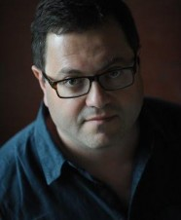

*Does Russia pose a threat to the west? With pithy and insightful observations, journalist and author Arkady Ostrovsky examines today’s political reality from the perspective of Putin's Russia.*

*Tracking a clear path from Gorbachev to Yeltsin to Putin, he paints a beguiling history: Putin's rise was not an aberration, but a deliberate move, generated by careful control of the media and security services.* Join Ostrovsky as he takes a closer look at what is real, what is fake, and what is possible in today's new world order.

Bio:

Arkady Ostrovsky is a Russian-born British journalist, and the Russian and Eastern European editor for *The Economist.* He holds a PhD in English Literature from Cambridge University. His translation of Tom Stoppard's trilogy, *The Coast of Utopia,* has been published and staged in Russia. He is a regular guest on the BBC, Sky News, and NPR, covering Russia and the former Soviet Union. He was awarded the 2016 Orwell Prize for his book *The Invention of Russia: From Gorbachev's Freedom to Putin's War*.

BREAK – 12pm to 12.30pm

**Tamika D. Mallory – The Women's March on Washington  
12.30pm – 1.30pm**

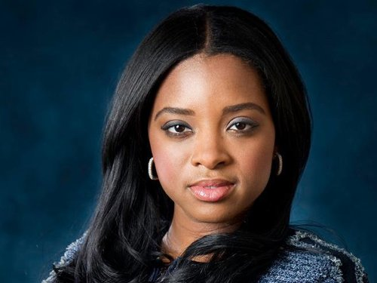

*Tamika D. Mallory has been protesting her entire life – from joining Reverend Al Sharpton's National Action Network at age fifteen, to working with the Obama administration on gun control legislation. As National Co-Chair of the Women's March on Washington, Mallory proved that women are the centre of resistance against the Trump presidency.*

*It was the largest single-day protest in US history, and worldwide participation was estimated at over five million. The Women's March sent a bold message to the new US government on its first day in office: women's rights are human rights.*

*In this fiery session, Mallory will reflect on* the wins of the Women's March, and what's next in the fight for equality.

Bio:

Tamika D. Mallory is a nationally recognised US activist who is well known as one of four Co-Chairs for the 2017 Women's March on Washington. President of Mallory Consulting, a strategic planning firm, and board member of The Gathering for Justice, Tamika has landed on the 2017 *Time* 100 Pioneers list and *Fortune*'s 2017 list of the World's Greatest Leaders. She is a prominent voice of civil rights, social justice, and feminism.

BREAK – 1.30pm to 1.45pm

**Rutger Bregman – Utopia for Realists**1.45pm – 2.15pm

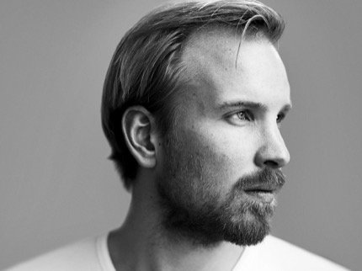

Our day-to-day reality – life expectancy, health, wealth and education were considered unrealistic and utopian in the eighteenth century. So, what's next? Join Rutger Bregman backstage to discuss how utopian ideals like a basic living income and a fifteen-hour workweek could become a reality in our lifetime. Bregman's transformational thinking bursts with hope and optimism, and will revolutionise your perspective on welfare, money, and society.

Bio:

Rutger Bregman has published four books on history, philosophy and economics. He won the Belgian Liberales prize for best non-fiction book in 2013 and has twice been nominated for the prestigious European Press Prize for his journalism work. His work has been featured in *The Washington Post*, *The Guardian* and on the *BBC*. In April 2017 he gave a TED talk on the benefits of universal basic income.