Part A: Application Cover Sheet  EGJ Working Groups Funding | 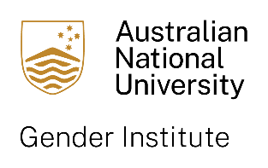

Enhancing Gender Justice through Transdisciplinary Research

ANU Gender Institute Working Groups Funding, Round 2 2025
Current members of the Gender Institute may request up to $60,000 AUD in Round 2.
This call is now open and closes at 5pm on 31 July 6 August 2025.

Outcomes will be notified by 15 September 2025.

Projects will run for 12-24 months and must commence within 6 months of award.
This funding program is separate from our other grants rounds, with different funding criteria and reporting requirements. For full guidelines, please see our website.

Lead applicant or co-applicant details
Name: | College/School/Institution:
Email:
Additional working group ANU-based researchers
Name: | College/School/Institution:
Email:

Name: | College/School/Institution:
Email:

Non-ANU and/or non-academic working group partners and associates
Name: | Institution/Organisation:
Email:

Name: | Institution/Organisation:
Email:

* Please add additional lines as necessary

Proposal title
* Full project description must be provided separately in Part B: Application Details

Summary of project (max. 100 words)

Summary of how the research will translate into action to enhance gender justice (max. 100 words)

Expected timeline

Funding*
Total amount requested: $
* Full budget breakdown and justification to be provided separately in Part B: Application Details

Endorsement of ANU Supervisor or Divisional Director or College Dean*
Name:

Date: | Signature:
* In the first instance please seek supervisor approval for your application, but if the project requires it, Director or Dean endorsement should be sought.

